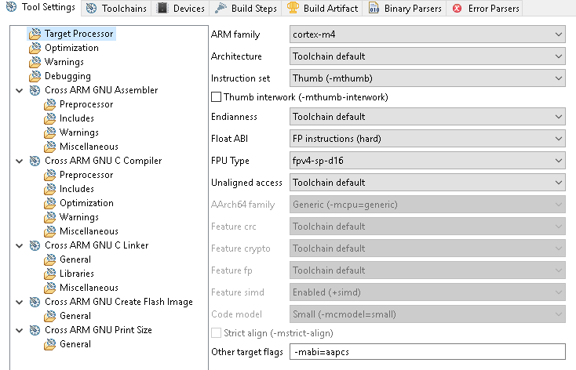

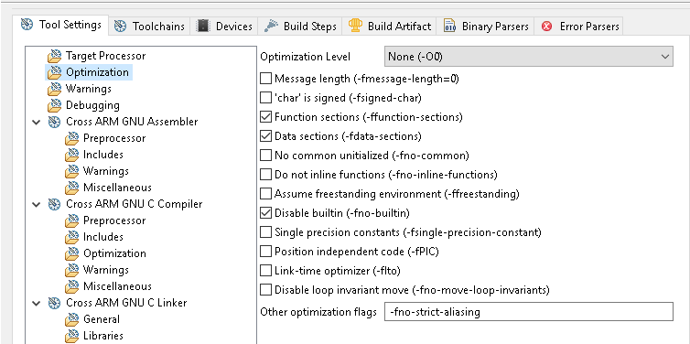

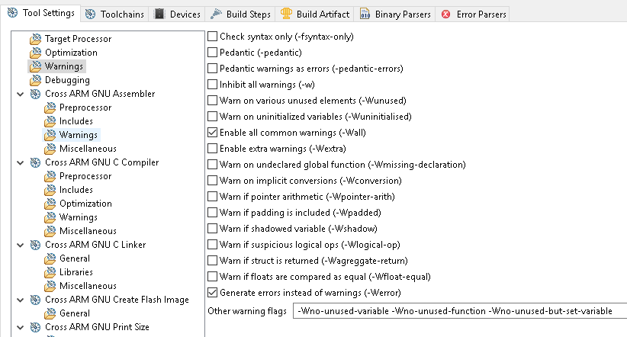
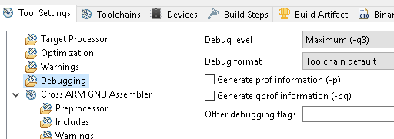
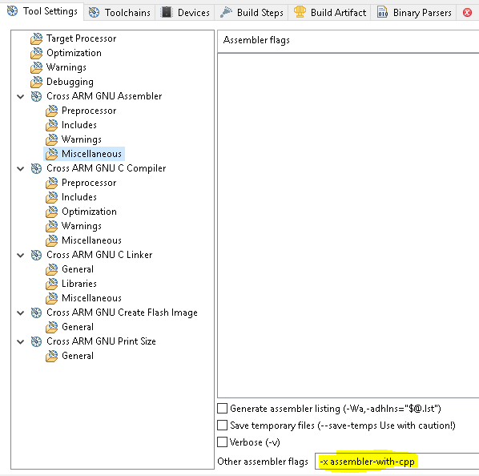
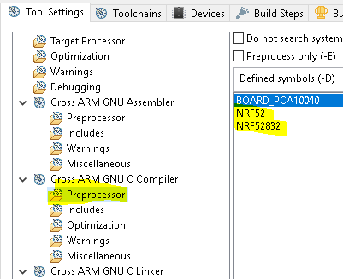
`

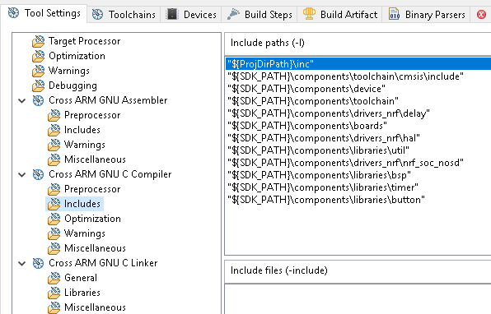
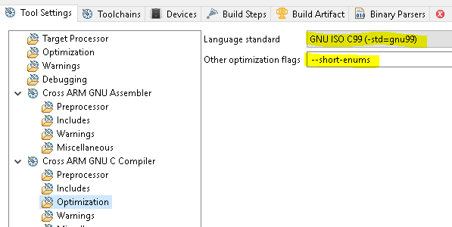

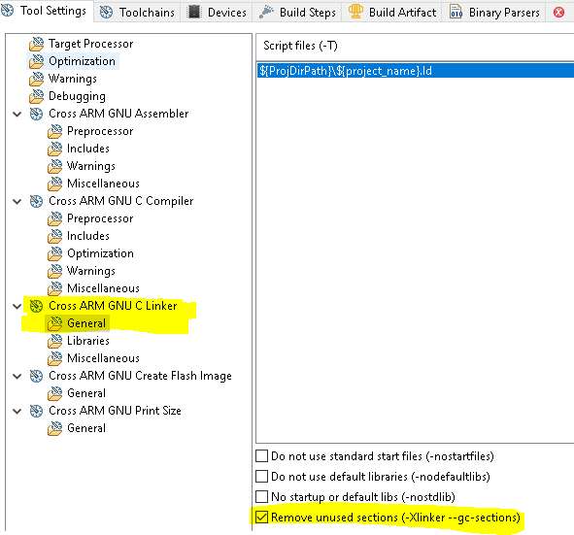

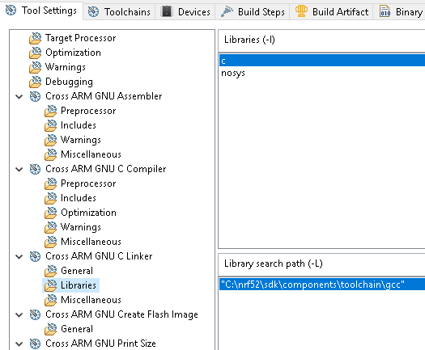
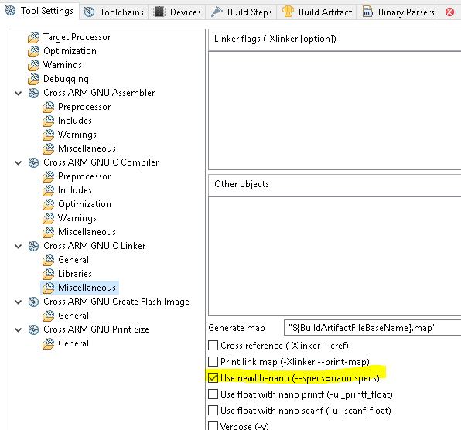

arm-none-eabi-gcc
-mcpu=cortex-m4
-mthumb
-mfloat-abi=hard
-mfpu=fpv4-sp-d16
-mabi=aapcs
-O3
-ffunction-sections
-fdata-sections
-fno-builtin
-fno-strict-aliasing
-Werror
-Wall
-Wno-unused-variable -Wno-unused-function -Wno-unused-but-set-variable
-g3
--short-enums
--std=gnu9

